Facebook and Google Play Developer Setups for Lets Quiz

Facebook

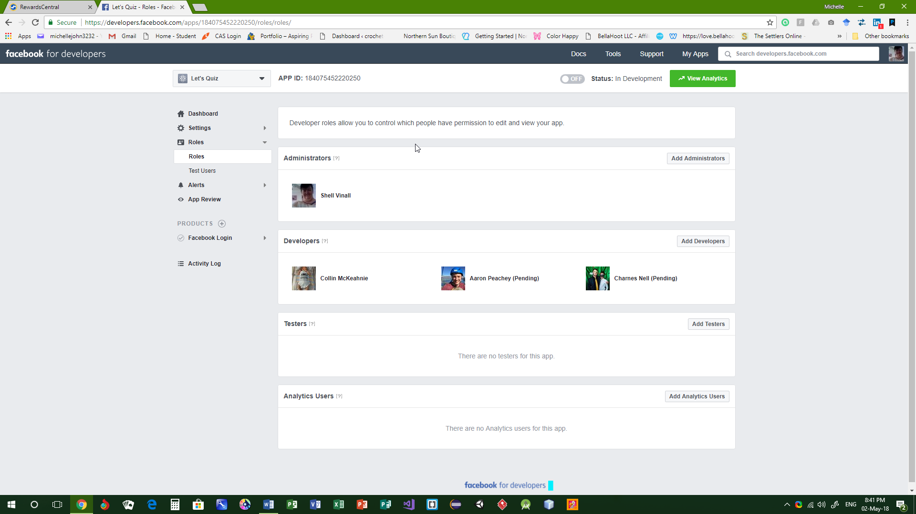

Google Play Services

